**MTA Public Safety Policy Reform Plan to Reduce Crime in Subway** *Organizational Review Part I | Siyong Liu | sl9404*

## **INTRODUCTION**

The Metropolitan Transportation Authority (MTA) is North America's largest transportation network, serving a population of 15.3 million people across a 5,000-square-mile travel area surrounding New York City through Long Island and southeastern New York State.

The MTA network comprises the nation’s largest bus fleet and more subway and commuter rail cars than all other U.S. transit systems combined. The MTA's operating agencies are MTA New York City Transit, MTA Bus, Long Island Rail Road (LIRR), Metro-North Railroad (MNR), and MTA Bridges and Tunnels.

## **ORGANIZATION STRUCTURE**

The current MTA organization chart is not available on the site. The chart I made is based on the people bio from MTA’s website and the 2018 MTA organization chart. The people highlighted in yellow are whose work is related to my project. The first line in this chart shows a part of officers who related to my project. The second line shows the president of different transit sections. The third line shows other chief officers. Resource from Transparency Program MTA Executive leadership Board[1]

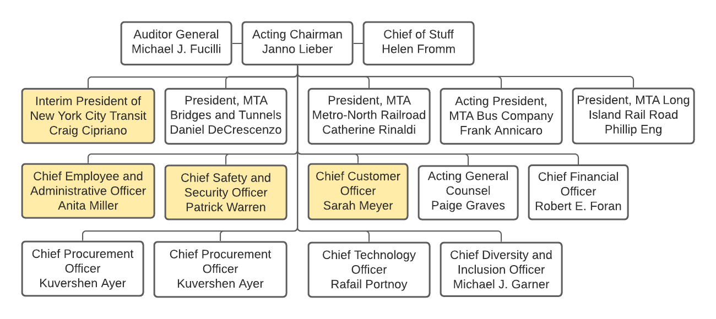

*Figure 1: MTA Organization Chart*

* Patrick Warren: Oversees the implementation of all-agency safety management policies.
* Craig Cipriano: manage the subway lines and system, and operations.
* Sarah Meyer: Charges with rebuilding and enhancing the customer experience
* Anita Miller: Oversees the strategic direction for labor and Work-Life Services.

## **Department Structure**

Department structure is a reference from the MTA departments and agencies page. Different from other government organizations, MTA is found by a combination of LIRR, MNR, and NYC transit system. MTA subdivisions are based on different types of services lines and regions. The departments highlighted in yellow are related to my project. I am focusing on the NYC Transit subway part and MTA Police. Resource from MTA Agencies and Departments[2].

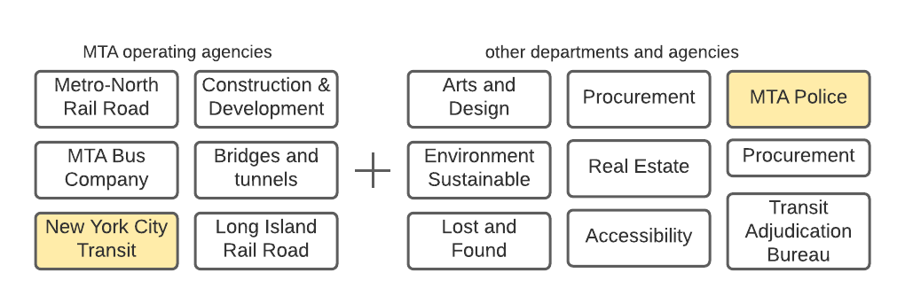

*Figure 2 MTA Departments*

|  |  |  |
| --- | --- | --- |
| Dept. | Leaders | Roles |
| MTA Police Department | * Joseph McGrann Chief of Operations, Administration * Sean Montgomery Chief of Special Services * Gary J. Beahan Sr. Chief of Patrol | Patrolling and securing Grand Central Terminal, Penn Station, and the infrastructure—including tracks, yards, shops, stations, and railroad crossings—of Metro-North, the LIRR, and the Staten Island Railway. |
| NYC Transit | * Craig Cipriano   Interim President of NYC Transit   * Frank Annicaro   Acting President, MTA Bus Company | NYC Transit operates NYC subway and bus services. Manage, maintain, and construct their Supporting facilities. |

*Table 1 MTA Police and NYC Transit Department Detail*

### **FUNDING & BUDGET**

An overview of the MTA expense schedule for 2022 - 2025 is included in Figure 3. As we can see the total revenue is $5635 M, which is significantly lower than previous years. The decline in the total revenue was due to a pandemic. The labor expense is the largest expense in MTA, which is $10478 M until mid-year. The non-labor expense is $3802 M. Resource from MTA Financial, and Budget Statement is shown below as per the MTA website[3]

Figure 3 MTA July 2021 Financial Plan 2022 – 2025

## **IDEAL ORGANIZATIONAL STRUCTURE**

In my opinion, MTA should be reformed. All departments should have more open communications and operate as one organization. AS we can see in the organizational chart, the MTA’s president is based on regions rather than services. The president should be in charge of the complete organization and make sure all services are integrated to better help the customers. This will increase customer satisfaction and increase ridership. All agencies under MTA should have the same policies, rules, and regulations. I understand from history all these agencies were separate entities, but it has been ages, MTA should at some point regulate the same service to all lines by their capital infrastructure plan over the years. This will help MTA in procurement strategy, they would not have to procure different types of assets for different infrastructure due to old infrastructure. Having large procurement which is the same across all MTA’s organizations will help MTA save money and use the asset where it is needed.

When I reviewed MTA public safety, I noticed a similar case all MTA agencies have different enforcement strategies. For example, MTA North and MTA LIRR have their own police while MTA NYC Transit has transit police. My safety program will also allow MTA to regulate this program across all agencies if this is successful in the subway. This is a cheap way to control crime and improve safety.

1. "MTA Executive Leadership." <https://new.mta.info/transparency/leadership/executive-leadership>. Accessed 4 Nov. 2021.
2. "Agencies and Departments - MTA." <https://new.mta.info/agency>. Accessed 4 Nov. 2021.
3. "Agencies and Departments - MTA." https://new.mta.info/agency. Accessed 4 Nov. 2021.